EXPERIEMNT:8: Create a Virtual Hard Disk and allocate the storage using VM ware Workstation.

STEP:1: CREATE A NEW VIRTUAL MACHINE KEEPT IT IN THE TYPICAL.

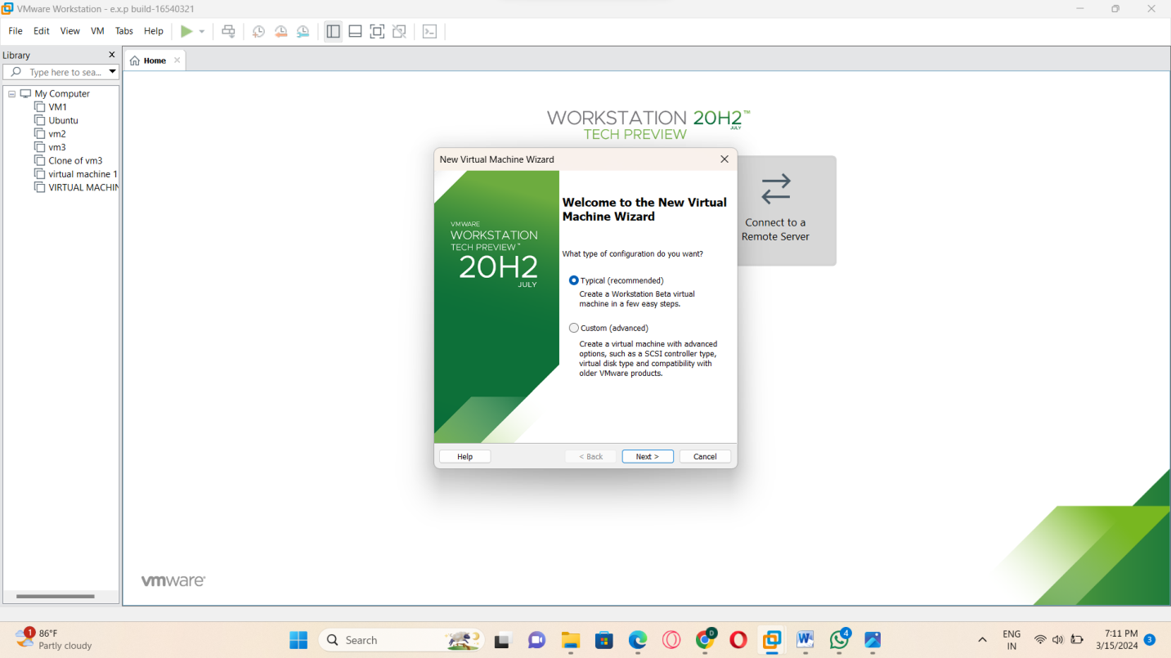

STEP:2:: SELECT THE GUEST OPERATION SYSTEM INSTALLATION:

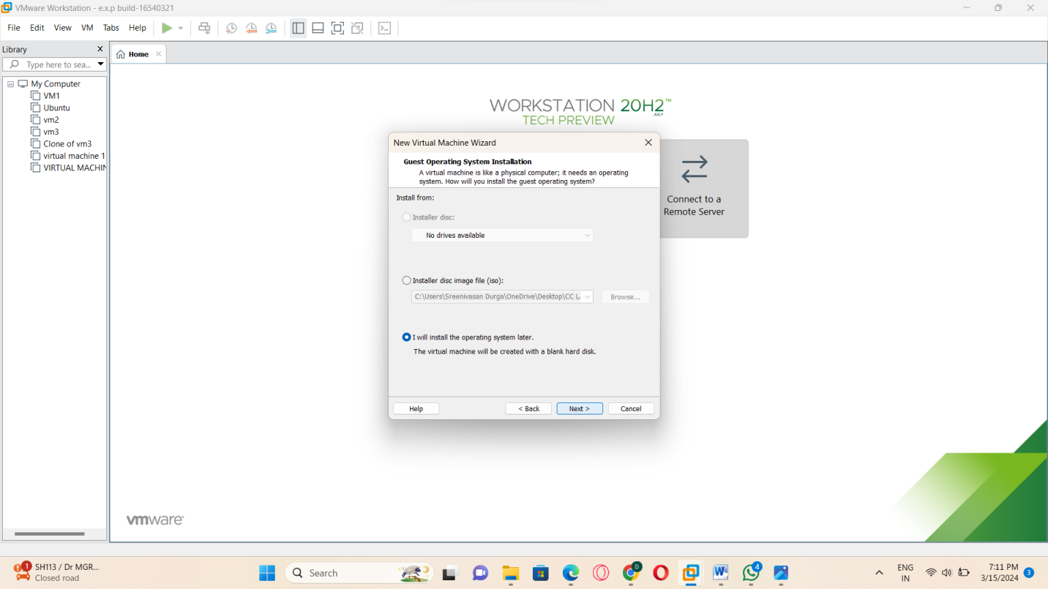

STEP:3:: SELECT ANY GUEST OPERATING SYSTEMS.

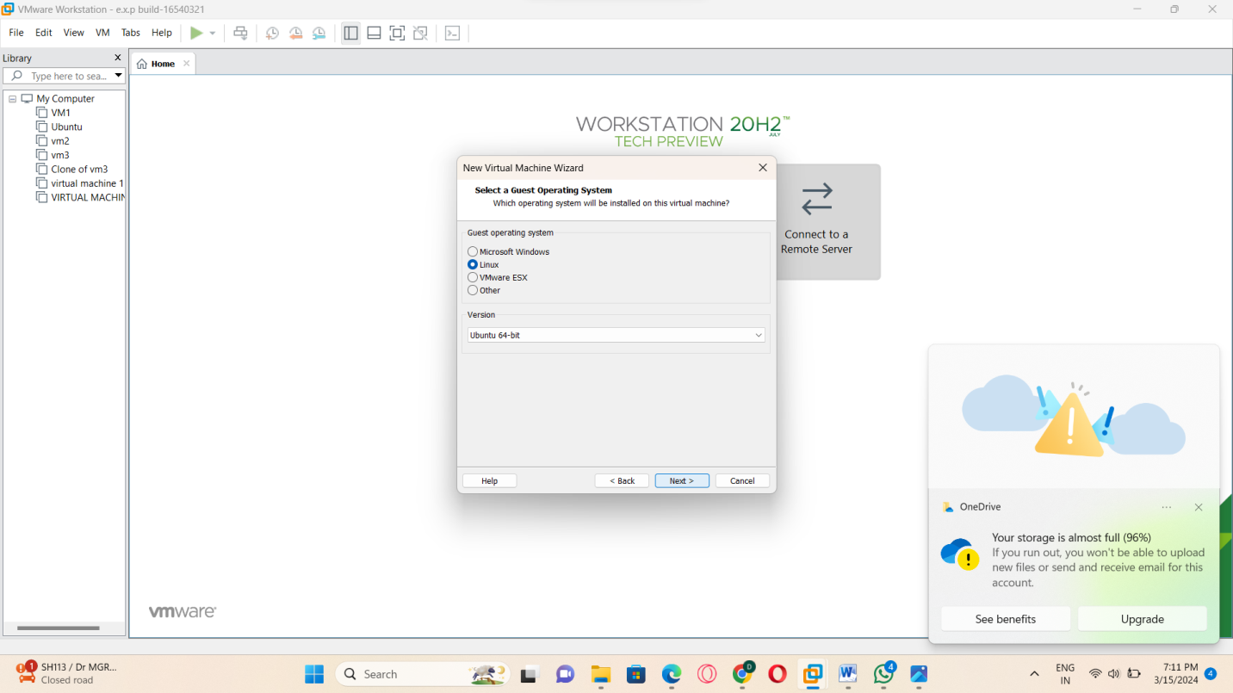

STEP:4:: THEN NAME THE VIRTUAL MACHINE:

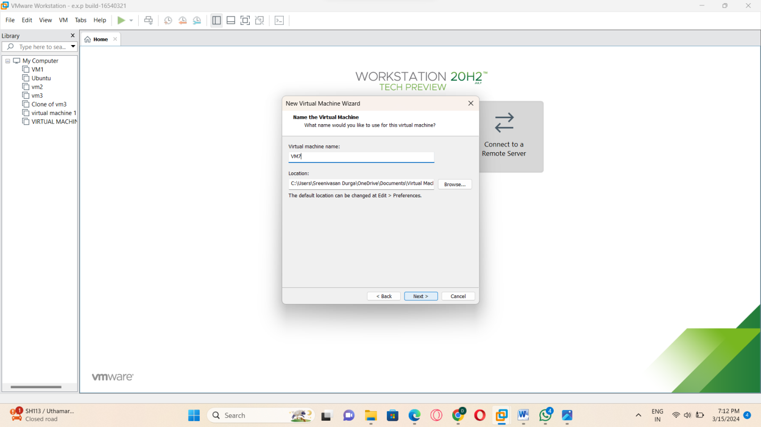

STEP:5:: AND THE SPECIFY THE DISK CAPACITY I.E(15GB).

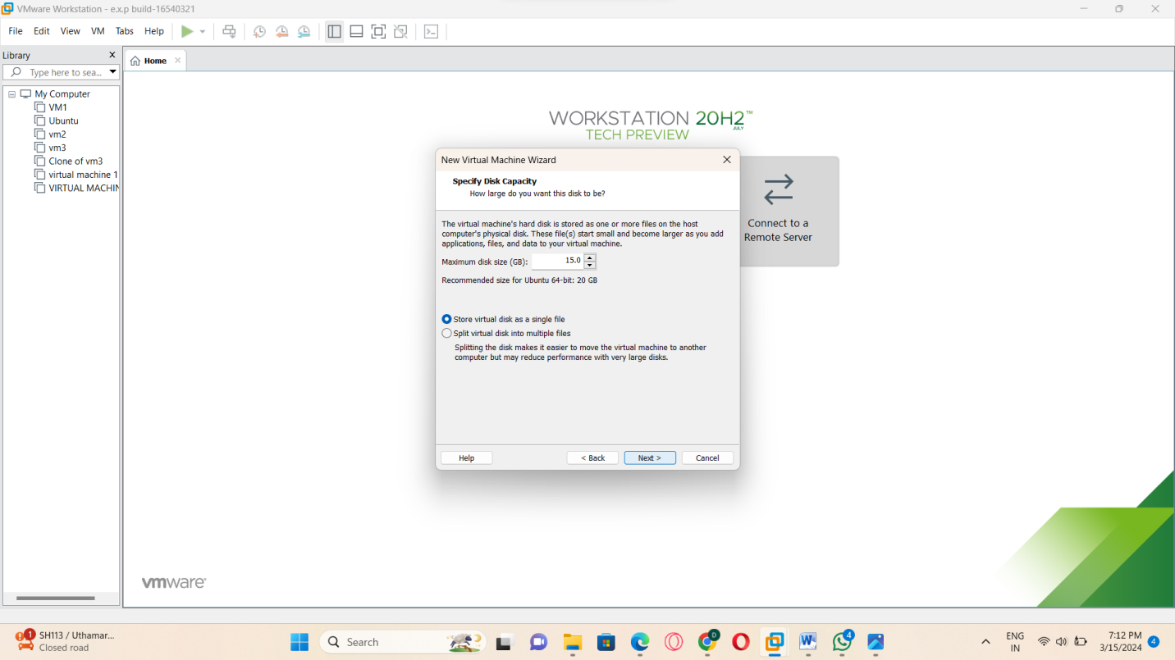

STEP:6:: READY TO CRAETE THE VIRTUAL MACHINE.

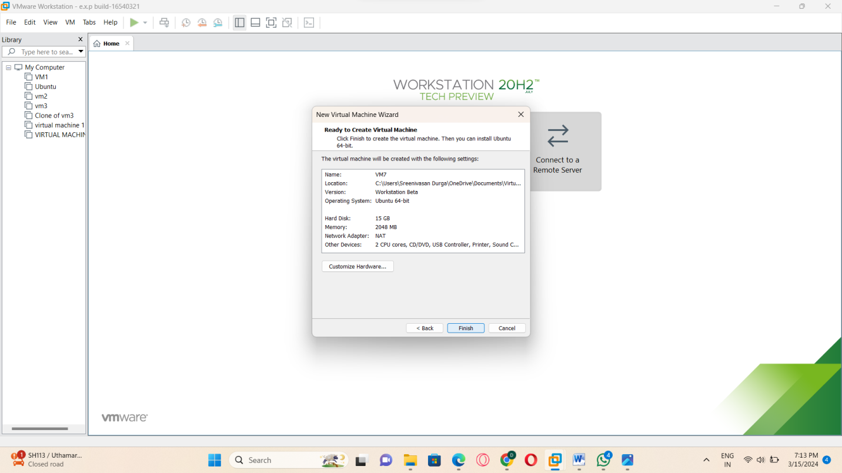

STEP:7: NOW IN THIS STAGE CHANGE THE CPU VALUE AS 1.

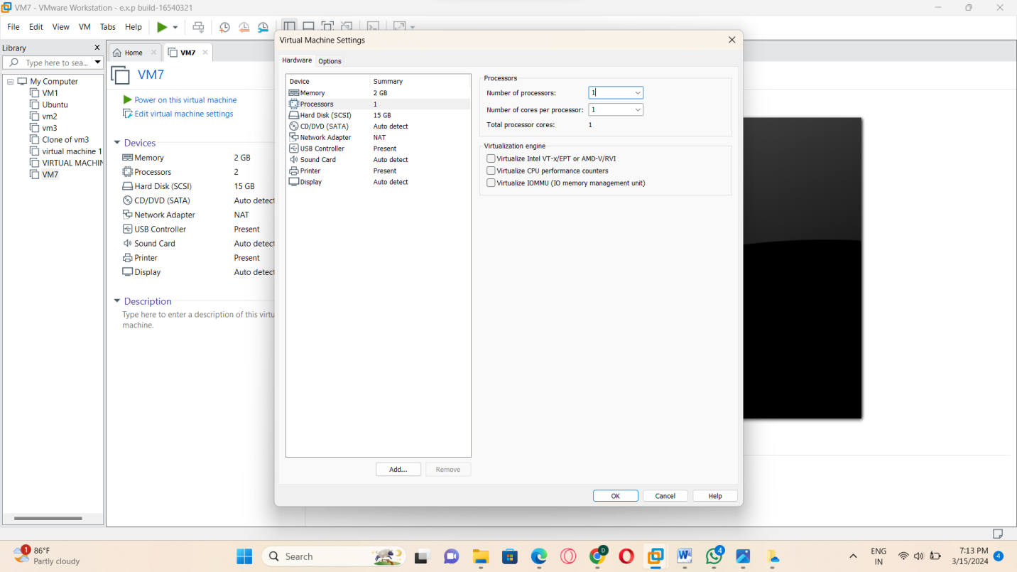

STEP:8: AND THE VM –WARE OUTPUT IS READY.

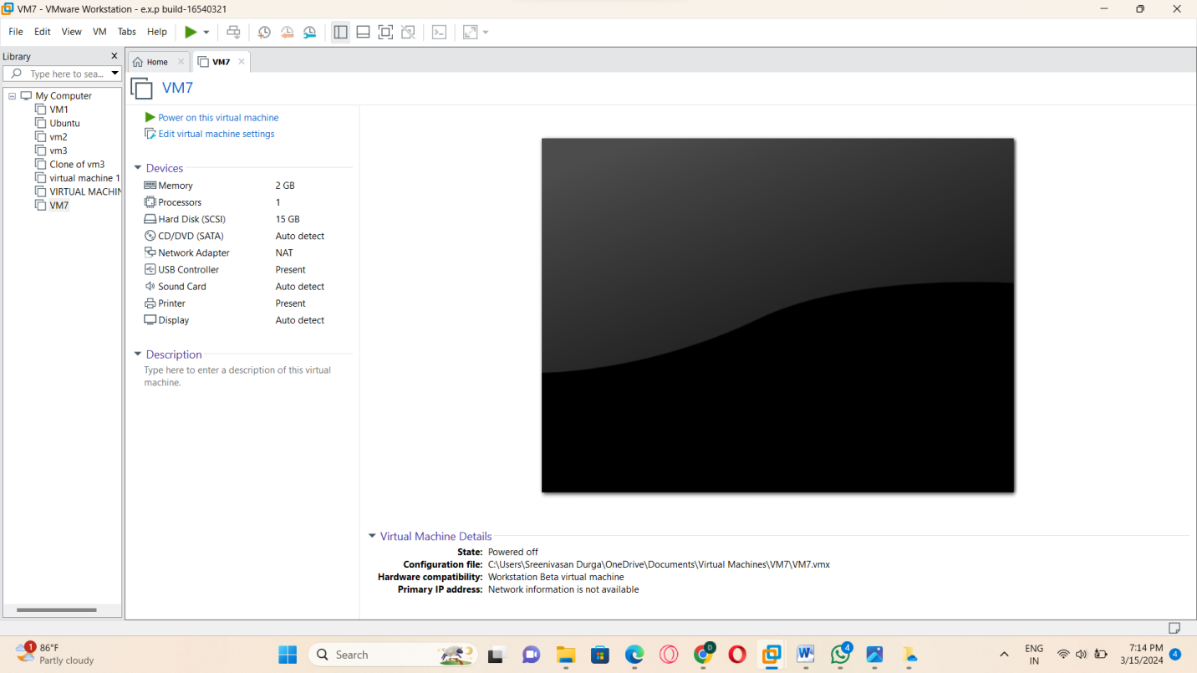

STEP:9: AND THEN CLICK THE HARD DISK.

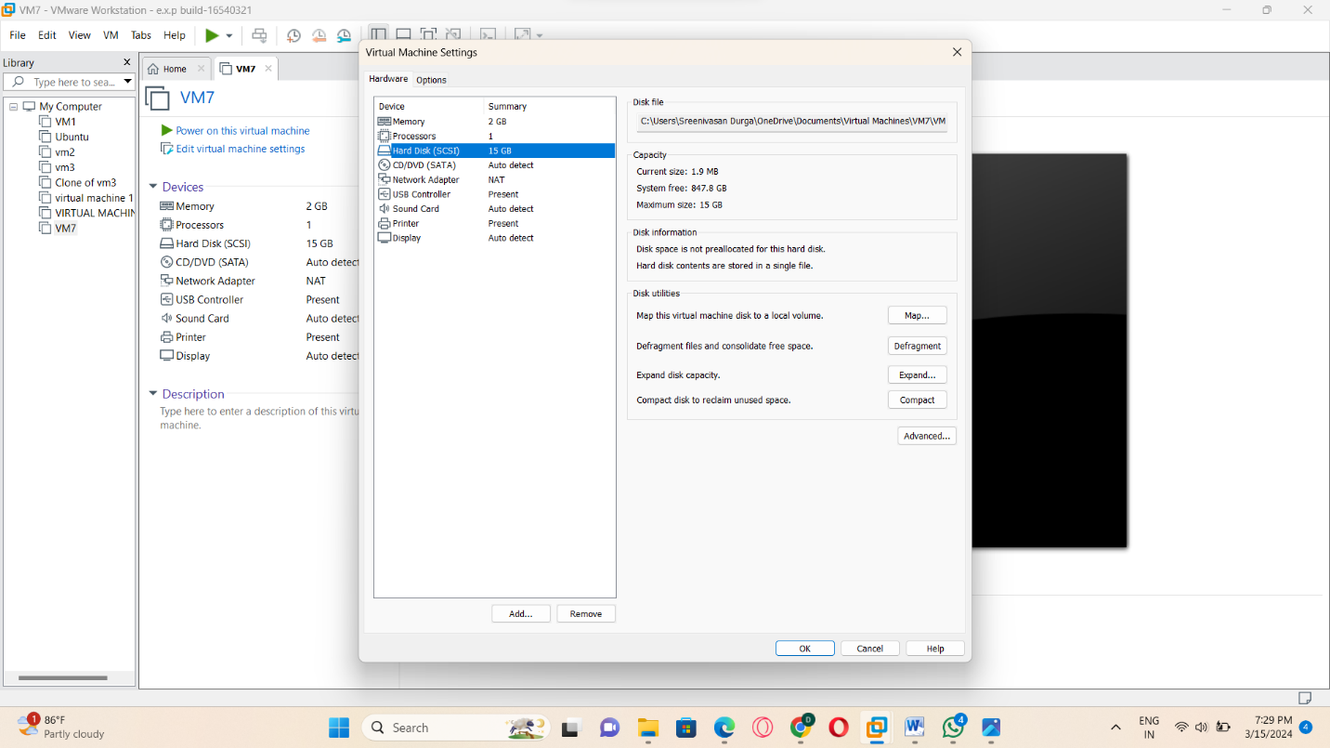

STEP:10: GO TO THE SCSI.

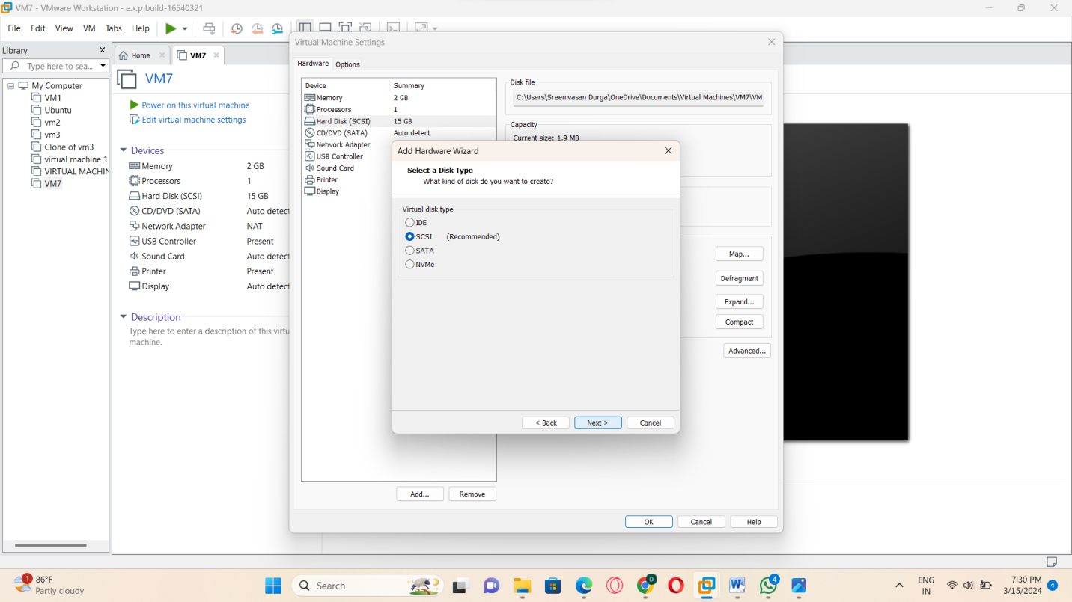

STEP:11: AND THEN TAP THE CREATE A NEW VIRTUAL MACHINE DISK.

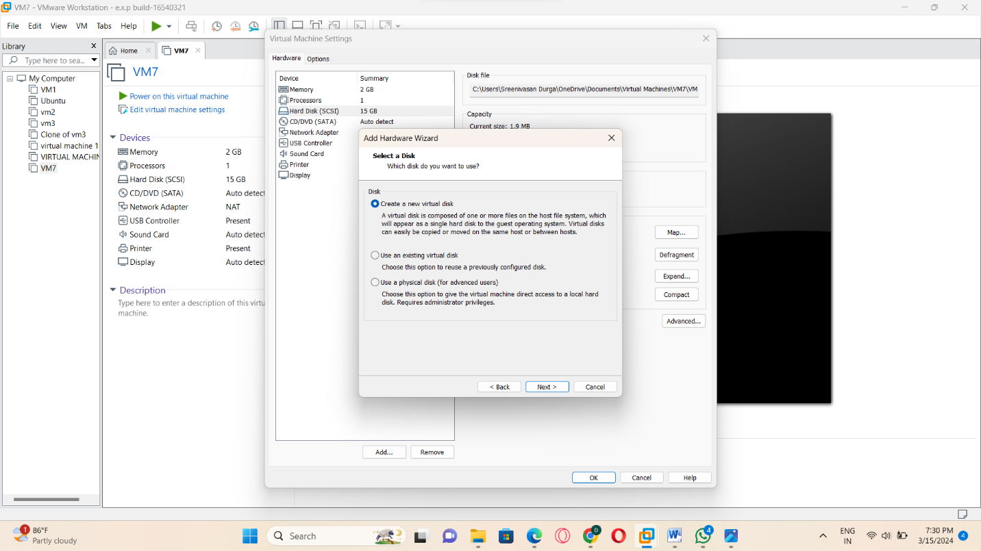

STEP:12: AND THEN LATER SPECIFY A DISK CAPACITY.

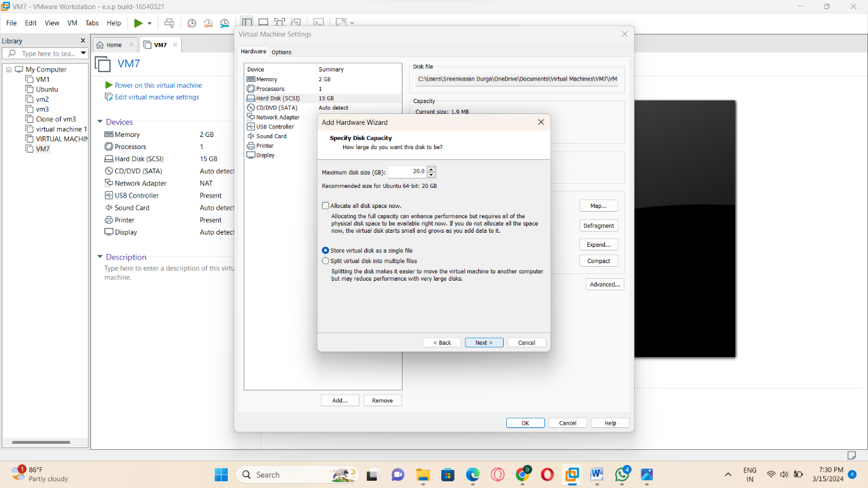

STEP:13: NAME THE DISK FILE NAME.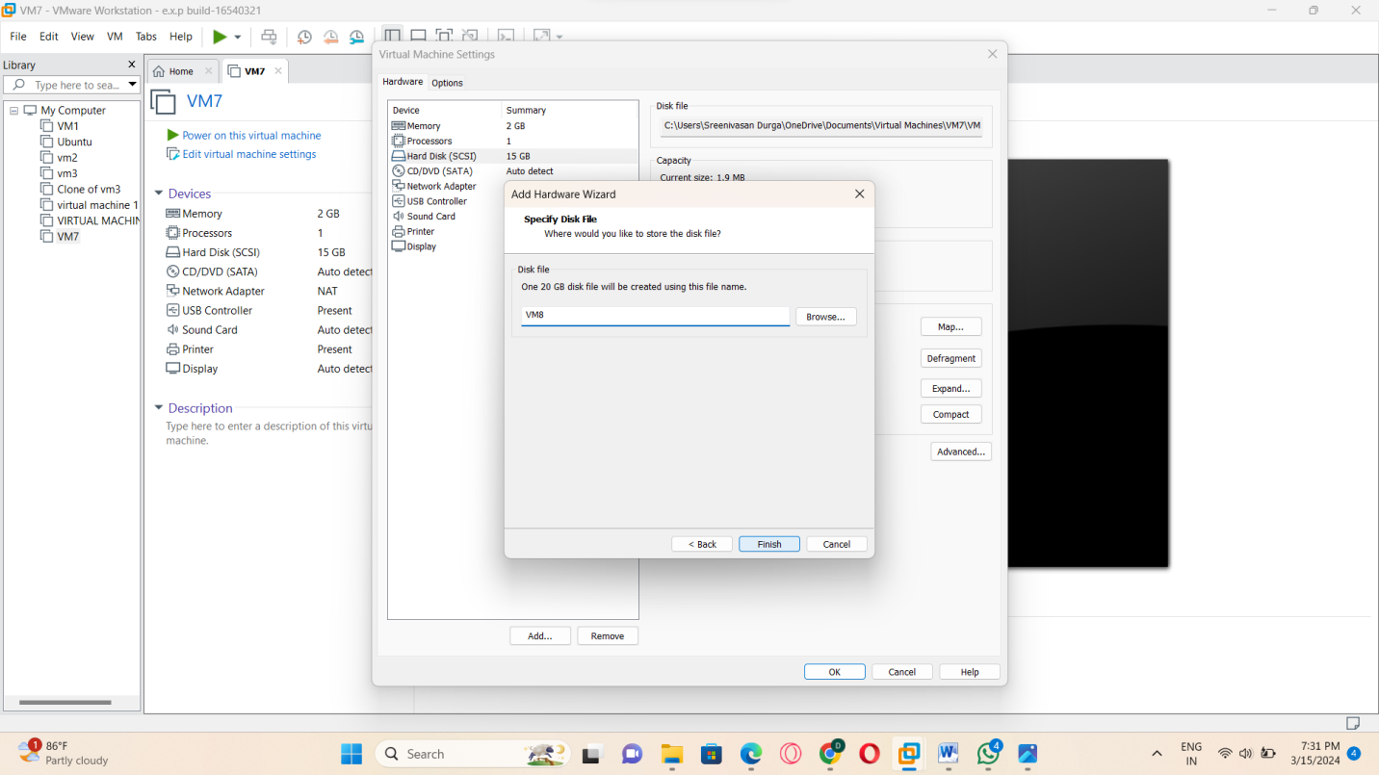

STEP:14: NOW ADD THE HARD DISK VALUE .

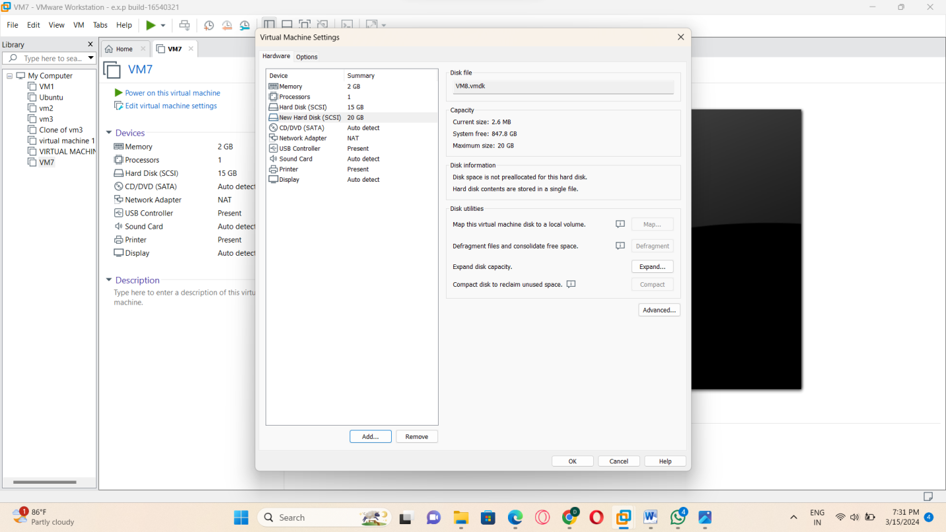

STEP:15: : HENCE IN THIS PART THE OUTPUT OF THE TWO HARD DISKS HAS BEEN SUCCESSFULLY GENERATED.

HARD DISK:15GB

HAR DISK:20GB.

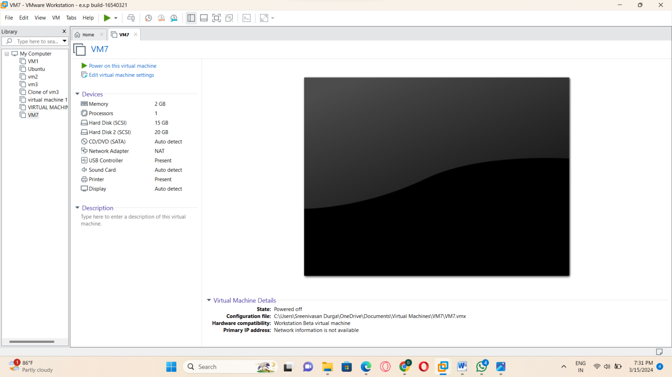

RESULT: THUS, THE PROGRAM IN THE VM-WARE HAS BEEN EXCEUTED SUCCESSFULLY.